# **Name: Abdurrahman Qureshi**

# **Roll No: 242466**

Practical No: 7

1) ****CONCAT**** **(String Function)**

QUERY:

SELECT CONCAT('Hello', ' ', 'World') AS result;

OUTPUT:

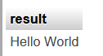

2) **LENGTH** **(String Function)**

QUERY:

SELECT LENGTH('MySQL String Functions') AS result;

OUTPUT:



3) ****LOWER**** **(String Function)**

QUERY:

SELECT LOWER('HELLO WORLD') AS result;

OUTPUT:

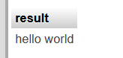

4) ****UPPER**** **(String Function)**

QUERY:

SELECT UPPER('hello world') AS result;

OUTPUT:

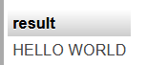

5) ****SUBSTRING**** **(String Function)**

QUERY:

SELECT SUBSTRING('MySQL String Functions', 7, 6) AS result;

OUTPUT:

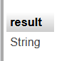

6) ****REVERSE**** **(String Function)**

QUERY:

SELECT REVERSE('MySQL') AS result;

OUTPUT:

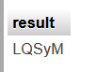

7) ****REPLACE**** **(String Function)**

QUERY:

SELECT REPLACE('Hello World', 'World', 'MySQL') AS result;

OUTPUT:

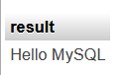

8) ****DATEDIFF**** **(Date Function)**

QUERY:

SELECT DATEDIFF('2024-12-31', '2024-10-07') AS days_difference;

OUTPUT:

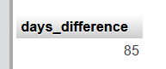

9) ****NOW**** **(Date Function)**

QUERY:

SELECT NOW() AS current_datetime;

OUTPUT:

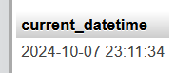

10) ****CURDATE**** **(Date Function)**

QUERY:

[**SELECT**](http://localhost/phpmyadmin/url.php?url=https://dev.mysql.com/doc/refman/8.0/en/select.html) CURDATE() AS c_date;

OUTPUT:

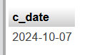

11) ****DATE**_**ADD**** **(Date Function)**

QUERY:

SELECT DATE_ADD('2024-10-07', INTERVAL 10 DAY) AS future_date;

OUTPUT:

